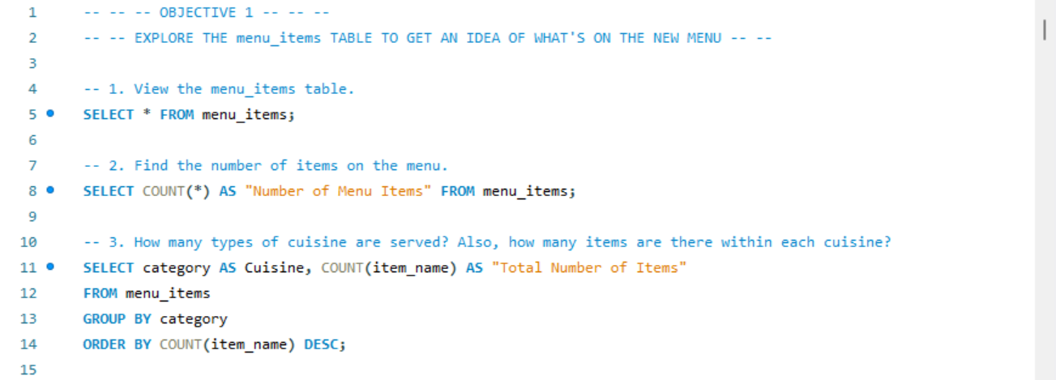

|  |  |  |  |
| --- | --- | --- | --- |
| menu_item_id | item_name | category | price |
| 101 | Hamburger | American | 12.95 |
| 102 | Cheeseburger | American | 13.95 |
| 103 | Hot Dog | American | 9.00 |
| 104 | Veggie Burger | American | 10.50 |
| 105 | Mac & Cheese | American | 7.00 |
| 106 | French Fries | American | 7.00 |
| 107 | Orange Chicken | Asian | 16.50 |
| 108 | Tofu Pad Thai | Asian | 14.50 |
| 109 | Korean Beef Bowl | Asian | 17.95 |
| 110 | Pork Ramen | Asian | 17.95 |
| 111 | California Roll | Asian | 11.95 |
| 112 | Salmon Roll | Asian | 14.95 |
| 113 | Edamame | Asian | 5.00 |
| 114 | Potstickers | Asian | 9.00 |
| 115 | Chicken Tacos | Mexican | 11.95 |
| 116 | Steak Tacos | Mexican | 13.95 |
| 117 | Chicken Burrito | Mexican | 12.95 |
| 118 | Steak Burrito | Mexican | 14.95 |
| 119 | Chicken Torta | Mexican | 11.95 |
| 120 | Steak Torta | Mexican | 13.95 |
| 121 | Cheese Quesadillas | Mexican | 10.50 |
| 122 | Chips & Salsa | Mexican | 7.00 |
| 123 | Chips & Guacamole | Mexican | 9.00 |
| 124 | Spaghetti | Italian | 14.50 |
| 125 | Spaghetti & Meatballs | Italian | 17.95 |
| 126 | Fettuccine Alfredo | Italian | 14.50 |
| 127 | Meat Lasagna | Italian | 17.95 |
| 128 | Cheese Lasagna | Italian | 15.50 |
| 129 | Mushroom Ravioli | Italian | 15.50 |
| 130 | Shrimp Scampi | Italian | 19.95 |
| 131 | Chicken Parmesan | Italian | 17.95 |
| 132 | Eggplant Parmesan | Italian | 16.95 |
|  |  |  |  |



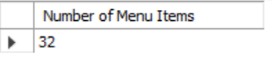



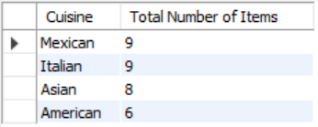

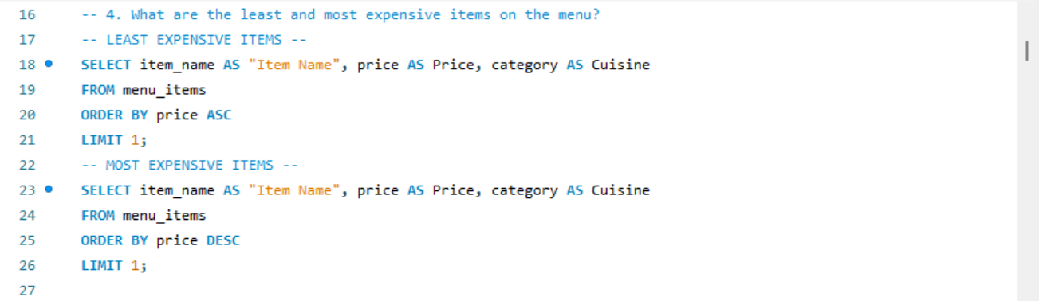







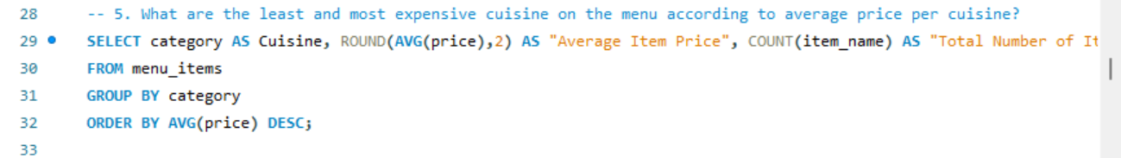

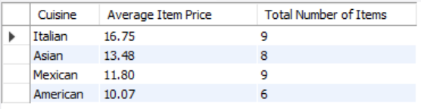

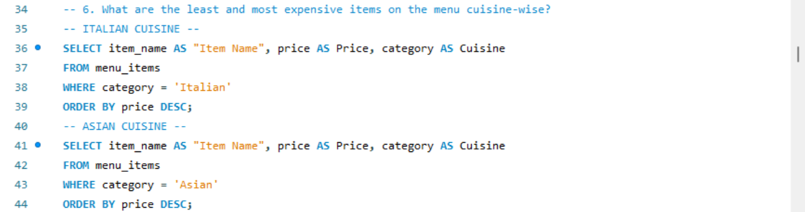

|  |  |  |
| --- | --- | --- |
| Item Name | Price | Cuisine |
| Shrimp Scampi | 19.95 | Italian |
| Spaghetti & Meatballs | 17.95 | Italian |
| Meat Lasagna | 17.95 | Italian |
| Chicken Parmesan | 17.95 | Italian |
| Eggplant Parmesan | 16.95 | Italian |
| Cheese Lasagna | 15.50 | Italian |
| Mushroom Ravioli | 15.50 | Italian |
| Spaghetti | 14.50 | Italian |
| Fettuccine Alfredo | 14.50 | Italian |



|  |  |  |
| --- | --- | --- |
| Item Name | Price | Cuisine |
| Korean Beef Bowl | 17.95 | Asian |
| Pork Ramen | 17.95 | Asian |
| Orange Chicken | 16.50 | Asian |
| Salmon Roll | 14.95 | Asian |
| Tofu Pad Thai | 14.50 | Asian |
| California Roll | 11.95 | Asian |
| Potstickers | 9.00 | Asian |
| Edamame | 5.00 | Asian |

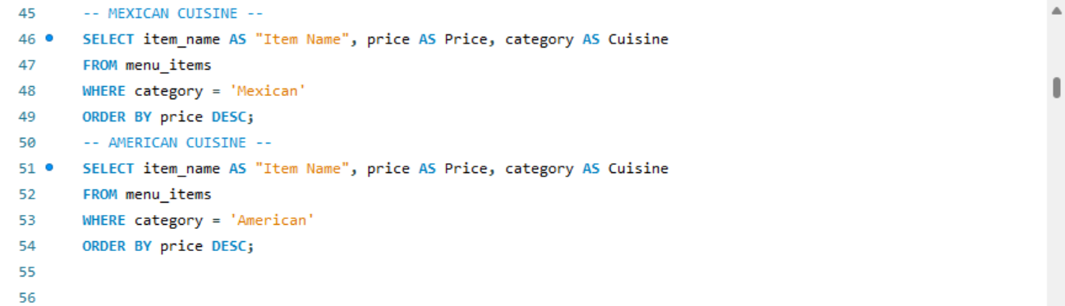

|  |  |  |
| --- | --- | --- |
| Item Name | Price | Cuisine |
| Steak Burrito | 14.95 | Mexican |
| Steak Tacos | 13.95 | Mexican |
| Steak Torta | 13.95 | Mexican |
| Chicken Burrito | 12.95 | Mexican |
| Chicken Tacos | 11.95 | Mexican |
| Chicken Torta | 11.95 | Mexican |
| Cheese Quesadillas | 10.50 | Mexican |
| Chips & Guacamole | 9.00 | Mexican |
| Chips & Salsa | 7.00 | Mexican |



|  |  |  |
| --- | --- | --- |
| Item Name | Price | Cuisine |
| Cheeseburger | 13.95 | American |
| Hamburger | 12.95 | American |
| Veggie Burger | 10.50 | American |
| Hot Dog | 9.00 | American |
| Mac & Cheese | 7.00 | American |
| French Fries | 7.00 | American |

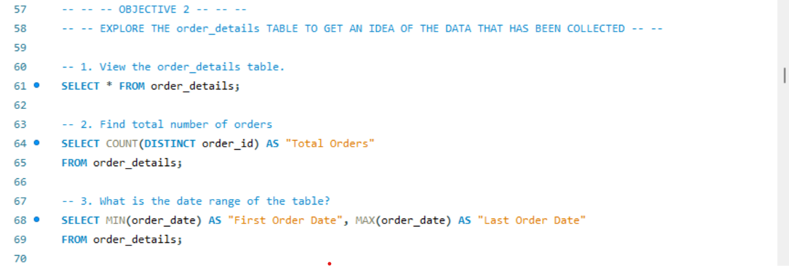

(The order table contains 12097 rows. Here, I have only included top 20 rows as above Query Result.)

|  |  |  |  |  |
| --- | --- | --- | --- | --- |
| order_details_id | order_id | order_date | order_time | item_id |
| 1 | 1 | 2023-01-01 | 11:38:36 | 109 |
| 2 | 2 | 2023-01-01 | 11:57:40 | 108 |
| 3 | 2 | 2023-01-01 | 11:57:40 | 124 |
| 4 | 2 | 2023-01-01 | 11:57:40 | 117 |
| 5 | 2 | 2023-01-01 | 11:57:40 | 129 |
| 6 | 2 | 2023-01-01 | 11:57:40 | 106 |
| 7 | 3 | 2023-01-01 | 12:12:28 | 117 |
| 8 | 3 | 2023-01-01 | 12:12:28 | 119 |
| 9 | 4 | 2023-01-01 | 12:16:31 | 117 |
| 10 | 5 | 2023-01-01 | 12:21:30 | 117 |
| 11 | 6 | 2023-01-01 | 12:29:36 | 101 |
| 12 | 6 | 2023-01-01 | 12:29:36 | 114 |
| 13 | 7 | 2023-01-01 | 12:50:37 | 123 |
| 14 | 8 | 2023-01-01 | 12:51:37 | 123 |
| 15 | 9 | 2023-01-01 | 12:52:01 | 108 |
| 16 | 9 | 2023-01-01 | 12:52:01 | 126 |
| 17 | 9 | 2023-01-01 | 12:52:01 | 110 |
| 18 | 9 | 2023-01-01 | 12:52:01 | 117 |
| 19 | 9 | 2023-01-01 | 12:52:01 | 117 |
| 20 | 9 | 2023-01-01 | 12:52:01 | 129 |
|  |  |  |  |  |









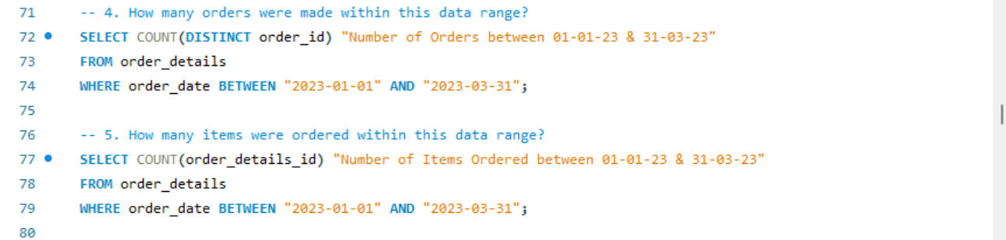







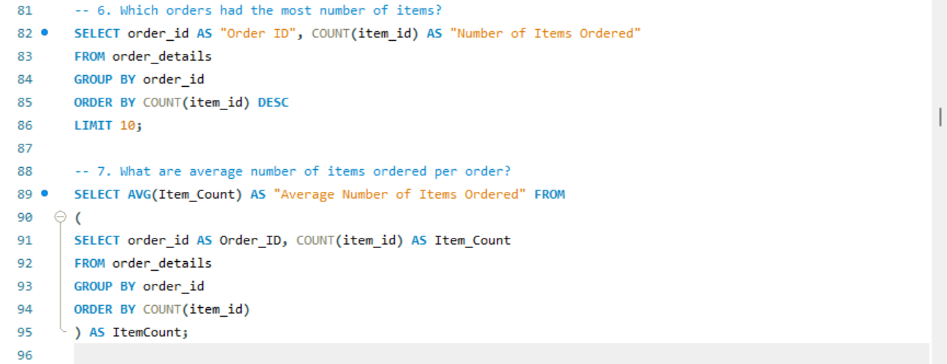

|  |  |
| --- | --- |
| Order ID | Number of Items Ordered |
| 2675 | 14 |
| 443 | 14 |
| 1957 | 14 |
| 3473 | 14 |
| 330 | 14 |
| 440 | 14 |
| 4305 | 14 |
| 1274 | 13 |
| 2126 | 13 |
| 1734 | 13 |

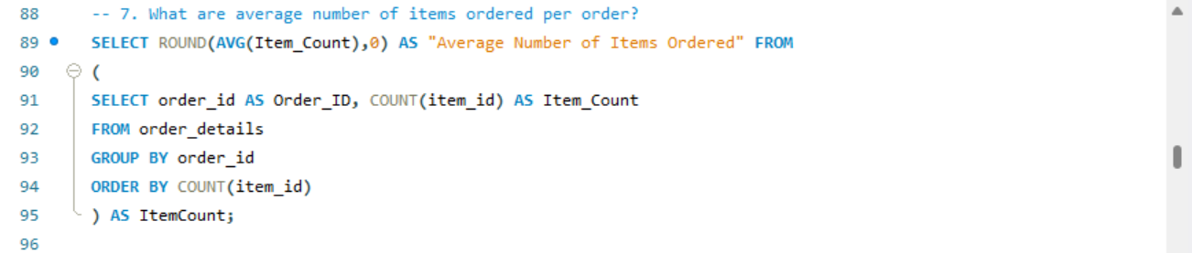



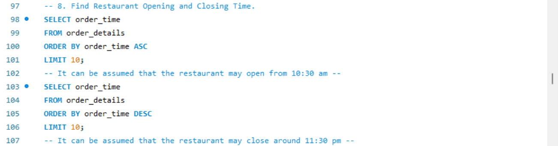

|  |
| --- |
| order_time |
| 10:50:46 |
| 10:50:46 |
| 10:50:46 |
| 10:54:03 |
| 10:54:03 |
| 11:15:19 |
| 11:15:19 |
| 11:15:19 |
| 11:15:19 |
| 11:15:43 |



|  |
| --- |
| order_time |
| 23:05:24 |
| 23:05:24 |
| 23:05:24 |
| 23:05:17 |
| 23:05:17 |
| 23:05:17 |
| 23:02:35 |
| 23:02:35 |
| 23:02:35 |
| 23:02:31 |

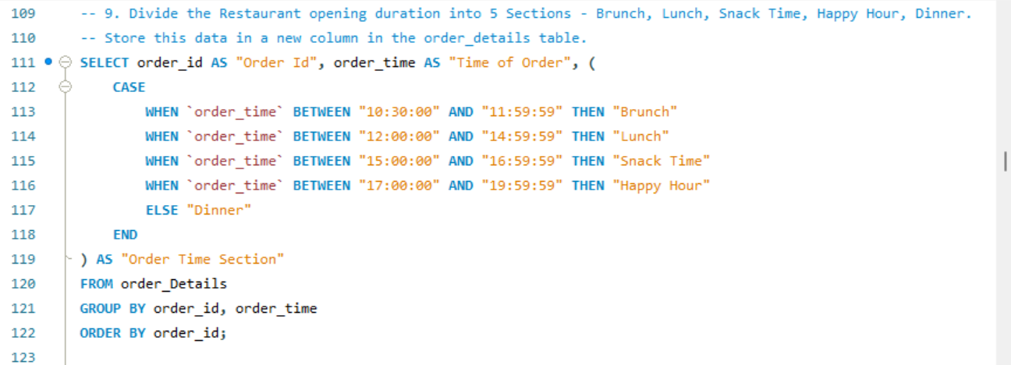

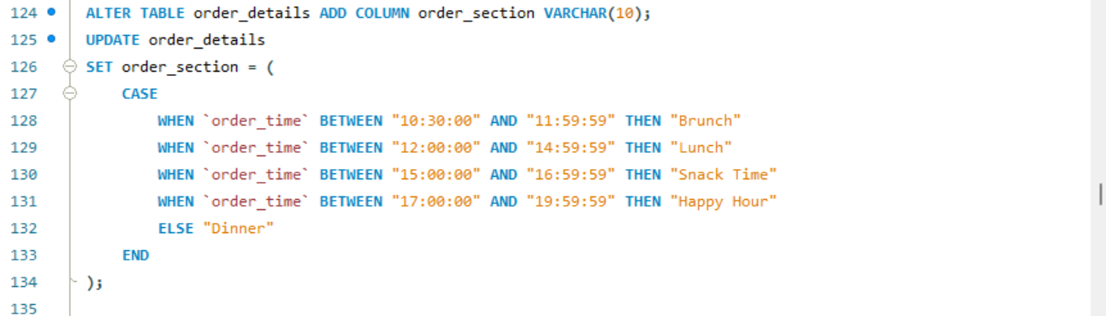

(Included only Top 20 rows from Query Result.)

|  |  |  |
| --- | --- | --- |
| Order ID | Time of Order | Order Time Section |
| 1 | 11:38:36 | Brunch |
| 2 | 11:57:40 | Brunch |
| 3 | 12:12:28 | Lunch |
| 4 | 12:16:31 | Lunch |
| 5 | 12:21:30 | Lunch |
| 6 | 12:29:36 | Lunch |
| 7 | 12:50:37 | Lunch |
| 8 | 12:51:37 | Lunch |
| 9 | 12:52:01 | Lunch |
| 10 | 13:00:15 | Lunch |
| 11 | 13:02:59 | Lunch |
| 12 | 13:04:41 | Lunch |
| 13 | 13:11:55 | Lunch |
| 14 | 13:14:19 | Lunch |
| 15 | 13:33:00 | Lunch |
| 16 | 13:34:07 | Lunch |
| 17 | 13:53:00 | Lunch |
| 18 | 13:57:08 | Lunch |
| 19 | 13:59:09 | Lunch |
| 20 | 14:03:08 | Lunch |

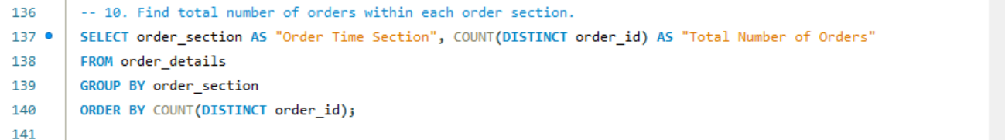

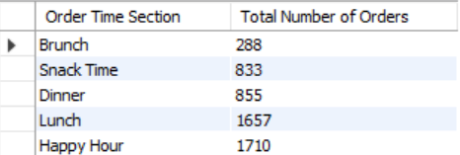

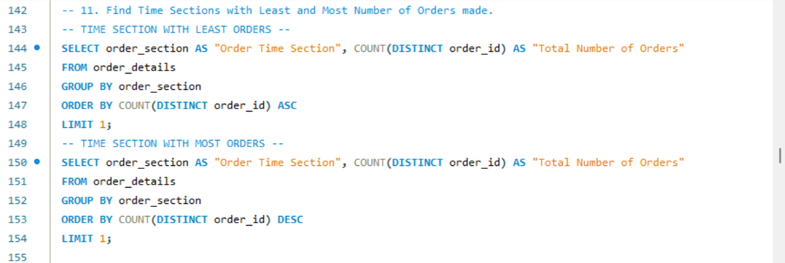







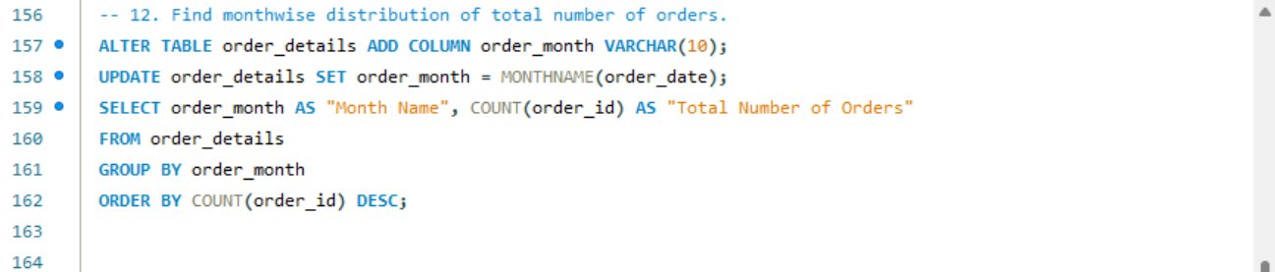

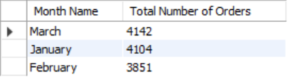

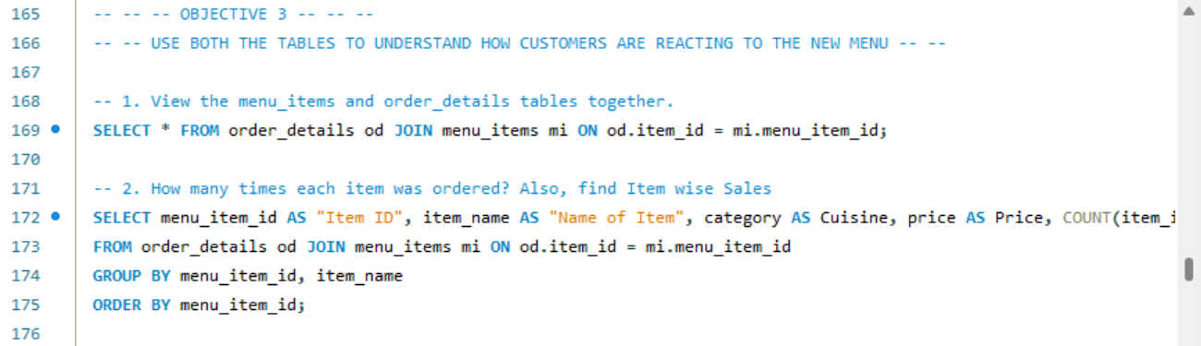

(Included only Top 20 rows from Query Result.)

|  |  |  |  |  |  |  |  |  |  |  |
| --- | --- | --- | --- | --- | --- | --- | --- | --- | --- | --- |
| order_details_id | order_id | order_date | order_time | item_id | order_section | order_month | menu_item_id | item_name | category | price |
| 1 | 1 | 2023-01-01 | 11:38:36 | 109 | Brunch | January | 109 | Korean Beef Bowl | Asian | 17.95 |
| 2 | 2 | 2023-01-01 | 11:57:40 | 108 | Brunch | January | 108 | Tofu Pad Thai | Asian | 14.50 |
| 3 | 2 | 2023-01-01 | 11:57:40 | 124 | Brunch | January | 124 | Spaghetti | Italian | 14.50 |
| 4 | 2 | 2023-01-01 | 11:57:40 | 117 | Brunch | January | 117 | Chicken Burrito | Mexican | 12.95 |
| 5 | 2 | 2023-01-01 | 11:57:40 | 129 | Brunch | January | 129 | Mushroom Ravioli | Italian | 15.50 |
| 6 | 2 | 2023-01-01 | 11:57:40 | 106 | Brunch | January | 106 | French Fries | American | 7.00 |
| 7 | 3 | 2023-01-01 | 12:12:28 | 117 | Lunch | January | 117 | Chicken Burrito | Mexican | 12.95 |
| 8 | 3 | 2023-01-01 | 12:12:28 | 119 | Lunch | January | 119 | Chicken Torta | Mexican | 11.95 |
| 9 | 4 | 2023-01-01 | 12:16:31 | 117 | Lunch | January | 117 | Chicken Burrito | Mexican | 12.95 |
| 10 | 5 | 2023-01-01 | 12:21:30 | 117 | Lunch | January | 117 | Chicken Burrito | Mexican | 12.95 |
| 11 | 6 | 2023-01-01 | 12:29:36 | 101 | Lunch | January | 101 | Hamburger | American | 12.95 |
| 12 | 6 | 2023-01-01 | 12:29:36 | 114 | Lunch | January | 114 | Potstickers | Asian | 9.00 |
| 13 | 7 | 2023-01-01 | 12:50:37 | 123 | Lunch | January | 123 | Chips & Guacamole | Mexican | 9.00 |
| 14 | 8 | 2023-01-01 | 12:51:37 | 123 | Lunch | January | 123 | Chips & Guacamole | Mexican | 9.00 |
| 15 | 9 | 2023-01-01 | 12:52:01 | 108 | Lunch | January | 108 | Tofu Pad Thai | Asian | 14.50 |
| 16 | 9 | 2023-01-01 | 12:52:01 | 126 | Lunch | January | 126 | Fettuccine Alfredo | Italian | 14.50 |
| 17 | 9 | 2023-01-01 | 12:52:01 | 110 | Lunch | January | 110 | Pork Ramen | Asian | 17.95 |
| 18 | 9 | 2023-01-01 | 12:52:01 | 117 | Lunch | January | 117 | Chicken Burrito | Mexican | 12.95 |
| 19 | 9 | 2023-01-01 | 12:52:01 | 117 | Lunch | January | 117 | Chicken Burrito | Mexican | 12.95 |
| 20 | 9 | 2023-01-01 | 12:52:01 | 129 | Lunch | January | 129 | Mushroom Ravioli | Italian | 15.50 |



|  |  |  |  |  |  |
| --- | --- | --- | --- | --- | --- |
| Item ID | Name of Item | Cuisine | Price | Number of Times Ordered | Total Sales |
| 101 | Hamburger | American | 12.95 | 622 | 8054.90 |
| 102 | Cheeseburger | American | 13.95 | 583 | 8132.85 |
| 103 | Hot Dog | American | 9.00 | 257 | 2313.00 |
| 104 | Veggie Burger | American | 10.50 | 238 | 2499.00 |
| 105 | Mac & Cheese | American | 7.00 | 463 | 3241.00 |
| 106 | French Fries | American | 7.00 | 571 | 3997.00 |
| 107 | Orange Chicken | Asian | 16.50 | 456 | 7524.00 |
| 108 | Tofu Pad Thai | Asian | 14.50 | 562 | 8149.00 |
| 109 | Korean Beef Bowl | Asian | 17.95 | 588 | 10554.60 |
| 110 | Pork Ramen | Asian | 17.95 | 360 | 6462.00 |
| 111 | California Roll | Asian | 11.95 | 355 | 4242.25 |
| 112 | Salmon Roll | Asian | 14.95 | 324 | 4843.80 |
| 113 | Edamame | Asian | 5.00 | 620 | 3100.00 |
| 114 | Potstickers | Asian | 9.00 | 205 | 1845.00 |
| 115 | Chicken Tacos | Mexican | 11.95 | 123 | 1469.85 |
| 116 | Steak Tacos | Mexican | 13.95 | 214 | 2985.30 |
| 117 | Chicken Burrito | Mexican | 12.95 | 455 | 5892.25 |
| 118 | Steak Burrito | Mexican | 14.95 | 354 | 5292.30 |
| 119 | Chicken Torta | Mexican | 11.95 | 379 | 4529.05 |
| 120 | Steak Torta | Mexican | 13.95 | 489 | 6821.55 |
| 121 | Cheese Quesadillas | Mexican | 10.50 | 233 | 2446.50 |
| 122 | Chips & Salsa | Mexican | 7.00 | 461 | 3227.00 |
| 123 | Chips & Guacamole | Mexican | 9.00 | 237 | 2133.00 |
| 124 | Spaghetti | Italian | 14.50 | 367 | 5321.50 |
| 125 | Spaghetti & Meatballs | Italian | 17.95 | 470 | 8436.50 |
| 126 | Fettuccine Alfredo | Italian | 14.50 | 249 | 3610.50 |
| 127 | Meat Lasagna | Italian | 17.95 | 273 | 4900.35 |
| 128 | Cheese Lasagna | Italian | 15.50 | 207 | 3208.50 |
| 129 | Mushroom Ravioli | Italian | 15.50 | 359 | 5564.50 |
| 130 | Shrimp Scampi | Italian | 19.95 | 239 | 4768.05 |
| 131 | Chicken Parmesan | Italian | 17.95 | 364 | 6533.80 |
| 132 | Eggplant Parmesan | Italian | 16.95 | 420 | 7119.00 |

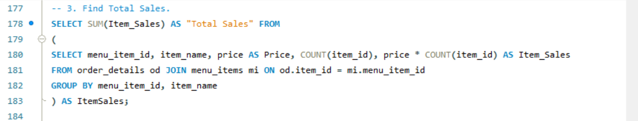



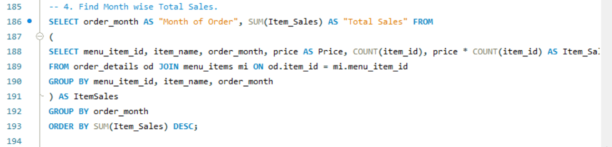

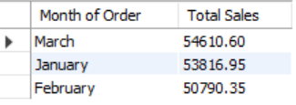

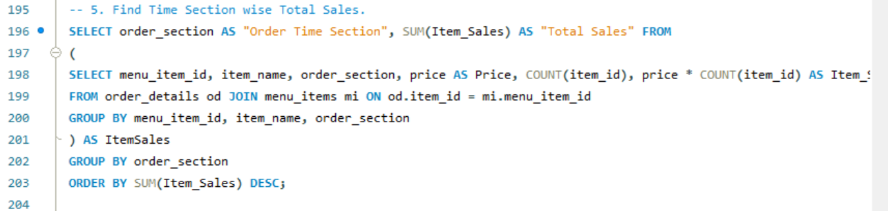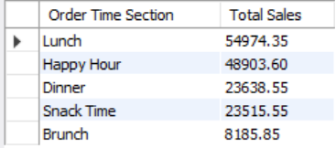

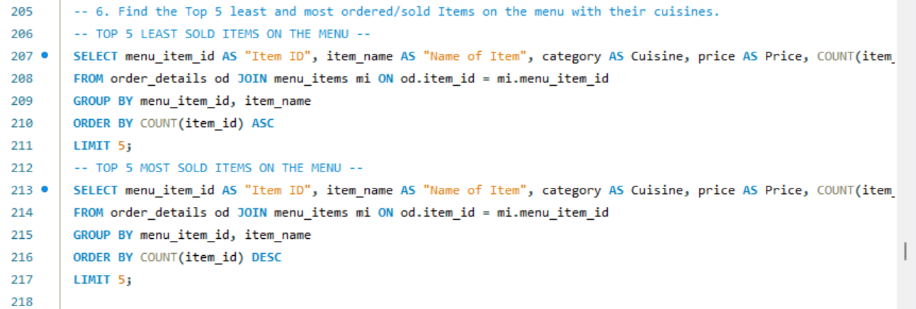

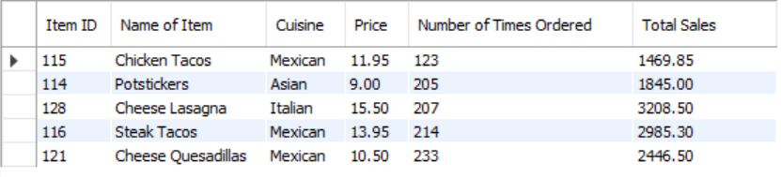



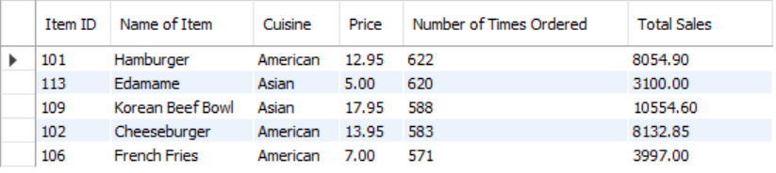

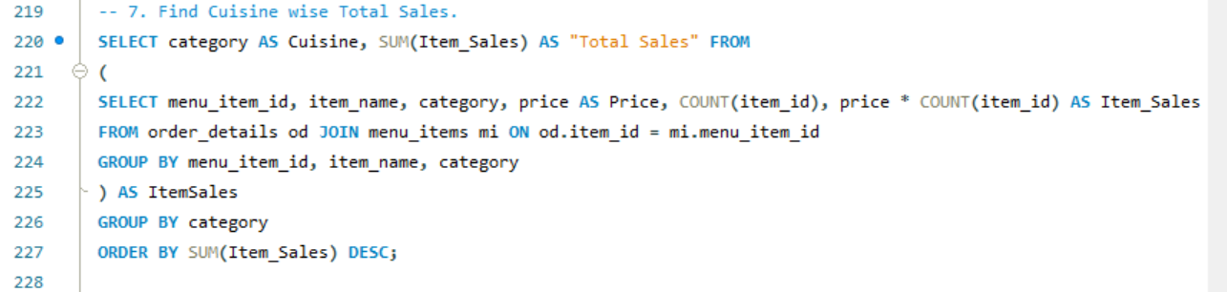

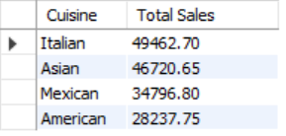

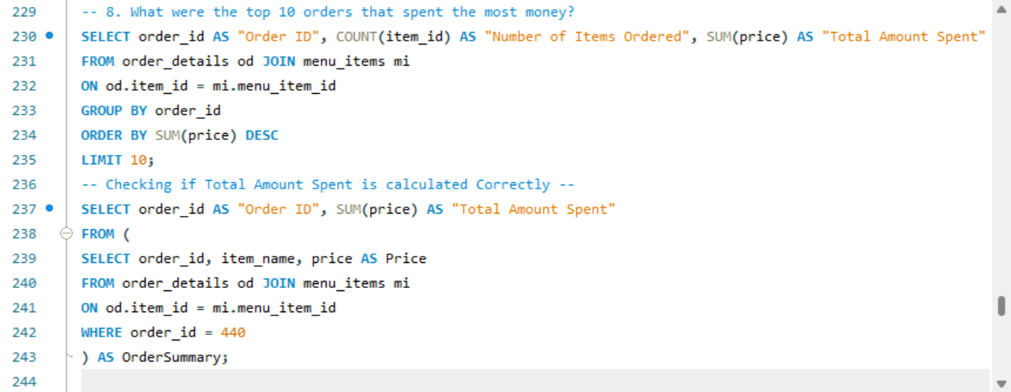

|  |  |  |
| --- | --- | --- |
| Order ID | Number of Items Ordered | Total Amount Spent |
| 440 | 14 | 192.15 |
| 2075 | 13 | 191.05 |
| 1957 | 14 | 190.10 |
| 330 | 14 | 189.70 |
| 2675 | 14 | 185.10 |
| 4482 | 13 | 184.50 |
| 1274 | 13 | 183.55 |
| 2188 | 13 | 182.65 |
| 3473 | 14 | 182.55 |
| 3583 | 13 | 179.60 |



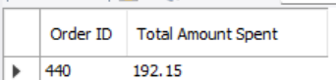

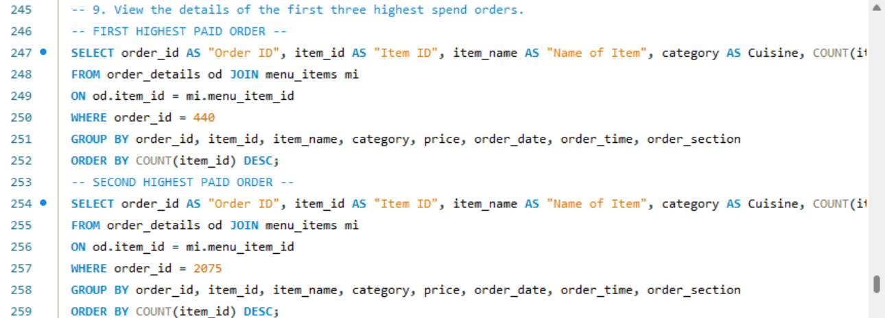

|  |  |  |  |  |  |  |  |  |  |
| --- | --- | --- | --- | --- | --- | --- | --- | --- | --- |
| Order ID | Item ID | Name of Item | Cuisine | Quantity | Date of Order | Time of Order | Order Time Section | Price | Item Total |
| 440 | 125 | Spaghetti & Meatballs | Italian | 2 | 2023-01-08 | 12:16:34 | Lunch | 17.95 | 35.90 |
| 440 | 126 | Fettuccine Alfredo | Italian | 2 | 2023-01-08 | 12:16:34 | Lunch | 14.50 | 29.00 |
| 440 | 116 | Steak Tacos | Mexican | 1 | 2023-01-08 | 12:16:34 | Lunch | 13.95 | 13.95 |
| 440 | 103 | Hot Dog | American | 1 | 2023-01-08 | 12:16:34 | Lunch | 9.00 | 9.00 |
| 440 | 124 | Spaghetti | Italian | 1 | 2023-01-08 | 12:16:34 | Lunch | 14.50 | 14.50 |
| 440 | 109 | Korean Beef Bowl | Asian | 1 | 2023-01-08 | 12:16:34 | Lunch | 17.95 | 17.95 |
| 440 | 127 | Meat Lasagna | Italian | 1 | 2023-01-08 | 12:16:34 | Lunch | 17.95 | 17.95 |
| 440 | 113 | Edamame | Asian | 1 | 2023-01-08 | 12:16:34 | Lunch | 5.00 | 5.00 |
| 440 | 122 | Chips & Salsa | Mexican | 1 | 2023-01-08 | 12:16:34 | Lunch | 7.00 | 7.00 |
| 440 | 131 | Chicken Parmesan | Italian | 1 | 2023-01-08 | 12:16:34 | Lunch | 17.95 | 17.95 |
| 440 | 106 | French Fries | American | 1 | 2023-01-08 | 12:16:34 | Lunch | 7.00 | 7.00 |
| 440 | 132 | Eggplant Parmesan | Italian | 1 | 2023-01-08 | 12:16:34 | Lunch | 16.95 | 16.95 |



|  |  |  |  |  |  |  |  |  |  |
| --- | --- | --- | --- | --- | --- | --- | --- | --- | --- |
| Order ID | Item ID | Name of Item | Cuisine | Quantity | Date of Order | Time of Order | Order Time Section | Price | Item Total |
| 2075 | 132 | Eggplant Parmesan | Italian | 2 | 2023-02-04 | 14:03:04 | Lunch | 16.95 | 33.90 |
| 2075 | 107 | Orange Chicken | Asian | 1 | 2023-02-04 | 14:03:04 | Lunch | 16.50 | 16.50 |
| 2075 | 115 | Chicken Tacos | Mexican | 1 | 2023-02-04 | 14:03:04 | Lunch | 11.95 | 11.95 |
| 2075 | 102 | Cheeseburger | American | 1 | 2023-02-04 | 14:03:04 | Lunch | 13.95 | 13.95 |
| 2075 | 124 | Spaghetti | Italian | 1 | 2023-02-04 | 14:03:04 | Lunch | 14.50 | 14.50 |
| 2075 | 125 | Spaghetti & Meatballs | Italian | 1 | 2023-02-04 | 14:03:04 | Lunch | 17.95 | 17.95 |
| 2075 | 127 | Meat Lasagna | Italian | 1 | 2023-02-04 | 14:03:04 | Lunch | 17.95 | 17.95 |
| 2075 | 129 | Mushroom Ravioli | Italian | 1 | 2023-02-04 | 14:03:04 | Lunch | 15.50 | 15.50 |
| 2075 | 111 | California Roll | Asian | 1 | 2023-02-04 | 14:03:04 | Lunch | 11.95 | 11.95 |
| 2075 | 112 | Salmon Roll | Asian | 1 | 2023-02-04 | 14:03:04 | Lunch | 14.95 | 14.95 |
| 2075 | 118 | Steak Burrito | Mexican | 1 | 2023-02-04 | 14:03:04 | Lunch | 14.95 | 14.95 |
| 2075 | 122 | Chips & Salsa | Mexican | 1 | 2023-02-04 | 14:03:04 | Lunch | 7.00 | 7.00 |

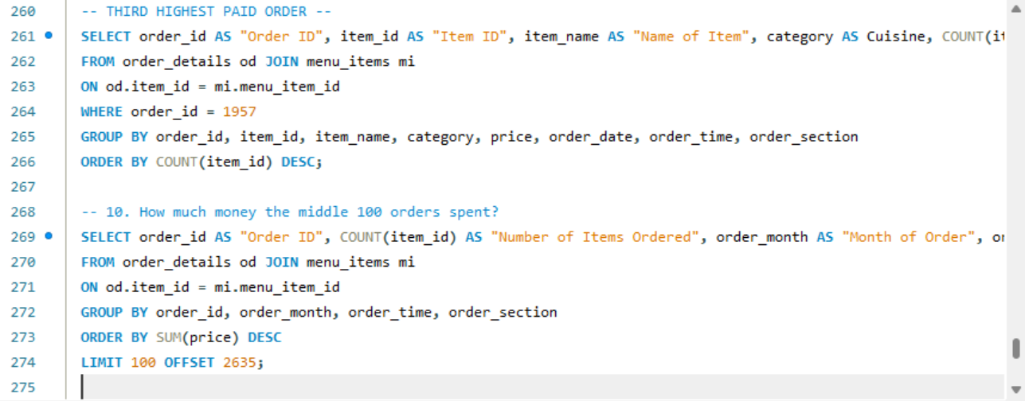

|  |  |  |  |  |  |  |  |  |  |
| --- | --- | --- | --- | --- | --- | --- | --- | --- | --- |
| Order ID | Item ID | Name of Item | Cuisine | Quantity | Date of Order | Time of Order | Order Time Section | Price | Item Total |
| 1957 | 118 | Steak Burrito | Mexican | 2 | 2023-02-02 | 14:50:01 | Lunch | 14.95 | 29.90 |
| 1957 | 131 | Chicken Parmesan | Italian | 2 | 2023-02-02 | 14:50:01 | Lunch | 17.95 | 35.90 |
| 1957 | 132 | Eggplant Parmesan | Italian | 2 | 2023-02-02 | 14:50:01 | Lunch | 16.95 | 33.90 |
| 1957 | 107 | Orange Chicken | Asian | 1 | 2023-02-02 | 14:50:01 | Lunch | 16.50 | 16.50 |
| 1957 | 103 | Hot Dog | American | 1 | 2023-02-02 | 14:50:01 | Lunch | 9.00 | 9.00 |
| 1957 | 104 | Veggie Burger | American | 1 | 2023-02-02 | 14:50:01 | Lunch | 10.50 | 10.50 |
| 1957 | 126 | Fettuccine Alfredo | Italian | 1 | 2023-02-02 | 14:50:01 | Lunch | 14.50 | 14.50 |
| 1957 | 117 | Chicken Burrito | Mexican | 1 | 2023-02-02 | 14:50:01 | Lunch | 12.95 | 12.95 |
| 1957 | 112 | Salmon Roll | Asian | 1 | 2023-02-02 | 14:50:01 | Lunch | 14.95 | 14.95 |
| 1957 | 113 | Edamame | Asian | 1 | 2023-02-02 | 14:50:01 | Lunch | 5.00 | 5.00 |
| 1957 | 106 | French Fries | American | 1 | 2023-02-02 | 14:50:01 | Lunch | 7.00 | 7.00 |



|  |  |  |  |  |  |
| --- | --- | --- | --- | --- | --- |
| Order ID | Number of Times Ordered | Month of Order | Time of Order | Order Time Section | Total Amount Spent |
| 2539 | 2 | February | 11:38:35 | Brunch | 24.95 |
| 2643 | 2 | February | 20:08:34 | Dinner | 24.95 |
| 2804 | 2 | February | 16:43:53 | Snack Time | 24.95 |
| 2807 | 2 | February | 17:13:02 | Happy Hour | 24.95 |
| 2819 | 2 | February | 19:26:51 | Happy Hour | 24.95 |
| 2826 | 2 | February | 22:40:27 | Dinner | 24.95 |
| 2909 | 2 | February | 14:21:14 | Lunch | 24.95 |
| 3098 | 2 | February | 15:26:00 | Snack Time | 24.95 |
| 3328 | 2 | February | 18:44:25 | Happy Hour | 24.95 |
| 3517 | 2 | February | 20:06:50 | Dinner | 24.95 |
| 3550 | 2 | March | 17:04:49 | Happy Hour | 24.95 |
| 3562 | 2 | March | 18:41:16 | Happy Hour | 24.95 |
| 3658 | 2 | March | 14:00:33 | Lunch | 24.95 |
| 3678 | 2 | March | 18:41:49 | Happy Hour | 24.95 |
| 3738 | 2 | March | 18:36:42 | Happy Hour | 24.95 |
| 3936 | 2 | March | 22:59:17 | Dinner | 24.95 |
| 4022 | 2 | March | 16:15:29 | Snack Time | 24.95 |
| 4026 | 2 | March | 16:46:41 | Snack Time | 24.95 |
| 4098 | 2 | March | 18:20:47 | Happy Hour | 24.95 |
| 4231 | 2 | March | 12:11:55 | Lunch | 24.95 |
| 4337 | 2 | March | 18:42:43 | Happy Hour | 24.95 |
| 4495 | 2 | March | 16:09:57 | Snack Time | 24.95 |
| 4552 | 2 | March | 12:50:24 | Lunch | 24.95 |
| 4556 | 2 | March | 13:09:57 | Lunch | 24.95 |
| 4689 | 2 | March | 16:54:26 | Snack Time | 24.95 |
| 4720 | 2 | March | 21:28:14 | Dinner | 24.95 |
| 4721 | 2 | March | 21:37:57 | Dinner | 24.95 |
| 4819 | 2 | March | 21:58:31 | Dinner | 24.95 |
| 4925 | 2 | March | 18:57:07 | Happy Hour | 24.95 |
| 4928 | 2 | March | 19:44:15 | Happy Hour | 24.95 |
| 5024 | 2 | March | 14:40:47 | Lunch | 24.95 |
| 5032 | 2 | March | 16:20:57 | Snack Time | 24.95 |
| 5122 | 2 | March | 20:26:45 | Dinner | 24.95 |
| 5185 | 2 | March | 20:24:32 | Dinner | 24.95 |
| 5233 | 2 | March | 18:53:49 | Happy Hour | 24.95 |
| 5352 | 2 | March | 18:04:35 | Happy Hour | 24.95 |
| 3802 | 2 | March | 18:03:09 | Happy Hour | 24.90 |
| 3967 | 2 | March | 16:48:23 | Snack Time | 24.90 |
| 4211 | 2 | March | 17:34:27 | Happy Hour | 24.90 |
| 4219 | 2 | March | 18:45:21 | Happy Hour | 24.90 |
| 4440 | 2 | March | 16:47:41 | Snack Time | 24.90 |
| 4572 | 2 | March | 17:23:10 | Happy Hour | 24.90 |
| 4607 | 2 | March | 11:40:57 | Brunch | 24.90 |
| 4636 | 2 | March | 17:58:30 | Happy Hour | 24.90 |
| 4991 | 2 | March | 21:09:19 | Dinner | 24.90 |
| 3 | 2 | January | 12:12:28 | Lunch | 24.90 |
| 102 | 2 | January | 17:54:04 | Happy Hour | 24.90 |
| 463 | 2 | January | 14:40:28 | Lunch | 24.90 |
| 542 | 2 | January | 18:08:06 | Happy Hour | 24.90 |
| 662 | 2 | January | 17:21:49 | Happy Hour | 24.90 |
| 1062 | 2 | January | 17:21:38 | Happy Hour | 24.90 |
| 1191 | 2 | January | 19:56:41 | Happy Hour | 24.90 |
| 1338 | 2 | January | 13:47:01 | Lunch | 24.90 |
| 1351 | 2 | January | 16:06:00 | Snack Time | 24.90 |
| 1560 | 2 | January | 12:56:17 | Lunch | 24.90 |
| 1703 | 2 | January | 17:47:55 | Happy Hour | 24.90 |
| 1782 | 2 | January | 21:05:29 | Dinner | 24.90 |
| 1834 | 2 | January | 20:26:06 | Dinner | 24.90 |
| 1853 | 2 | February | 12:12:59 | Lunch | 24.90 |
| 1916 | 2 | February | 19:27:59 | Happy Hour | 24.90 |
| 1920 | 2 | February | 20:04:38 | Dinner | 24.90 |
| 2148 | 2 | February | 18:15:37 | Happy Hour | 24.90 |
| 2535 | 2 | February | 21:45:46 | Dinner | 24.90 |
| 2555 | 2 | February | 14:00:00 | Lunch | 24.90 |
| 1720 | 2 | January | 20:37:53 | Dinner | 24.50 |
| 1792 | 2 | January | 11:31:03 | Brunch | 24.50 |
| 1927 | 3 | February | 21:31:03 | Dinner | 24.50 |
| 2113 | 2 | February | 22:16:08 | Dinner | 24.50 |
| 2339 | 2 | February | 18:54:41 | Happy Hour | 24.50 |
| 3048 | 3 | February | 17:45:15 | Happy Hour | 24.50 |
| 3340 | 2 | February | 20:41:17 | Dinner | 24.50 |
| 3730 | 2 | March | 17:55:40 | Happy Hour | 24.50 |
| 4387 | 2 | March | 18:01:50 | Happy Hour | 24.50 |
| 5198 | 2 | March | 12:09:12 | Lunch | 24.50 |
| 5249 | 3 | March | 11:25:41 | Brunch | 24.50 |
| 5301 | 2 | March | 21:04:56 | Dinner | 24.50 |
| 4726 | 2 | March | 22:28:53 | Dinner | 24.45 |
| 320 | 2 | January | 12:46:40 | Lunch | 24.45 |
| 418 | 2 | January | 18:40:11 | Happy Hour | 24.45 |
| 584 | 2 | January | 15:05:29 | Snack Time | 24.45 |
| 680 | 2 | January | 21:07:30 | Dinner | 24.45 |
| 761 | 2 | January | 16:30:20 | Snack Time | 24.45 |
| 888 | 2 | January | 17:14:27 | Happy Hour | 24.45 |
| 2859 | 2 | February | 16:56:21 | Snack Time | 24.45 |
| 3036 | 2 | February | 15:14:47 | Snack Time | 24.45 |
| 47 | 2 | January | 18:26:34 | Happy Hour | 23.95 |
| 53 | 2 | January | 18:54:17 | Happy Hour | 23.95 |
| 206 | 3 | January | 11:45:10 | Brunch | 23.95 |
| 382 | 2 | January | 12:33:07 | Lunch | 23.95 |
| 656 | 2 | January | 16:44:49 | Snack Time | 23.95 |
| 746 | 2 | January | 13:41:13 | Lunch | 23.95 |
| 816 | 2 | January | 17:04:08 | Happy Hour | 23.95 |
| 1006 | 2 | January | 18:28:12 | Happy Hour | 23.95 |
| 1349 | 2 | January | 16:03:08 | Snack Time | 23.95 |
| 1408 | 2 | January | 16:05:14 | Snack Time | 23.95 |
| 1529 | 2 | January | 15:35:32 | Snack Time | 23.95 |
| 1652 | 2 | January | 16:56:19 | Snack Time | 23.95 |
| 1758 | 2 | January | 17:38:25 | Happy Hour | 23.95 |
| 1788 | 2 | January | 21:35:08 | Dinner | 23.95 |
| 1844 | 2 | January | 22:09:40 | Dinner | 23.95 |

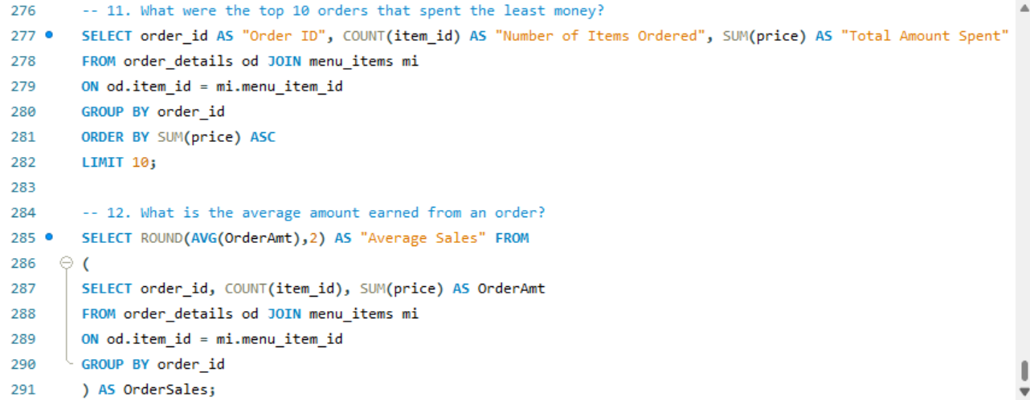

|  |  |  |
| --- | --- | --- |
| Order ID | Number of Times Ordered | Total Amount Spent |
| 349 | 1 | 5.00 |
| 150 | 1 | 5.00 |
| 371 | 1 | 5.00 |
| 211 | 1 | 5.00 |
| 112 | 1 | 5.00 |
| 132 | 1 | 5.00 |
| 84 | 1 | 5.00 |
| 127 | 1 | 5.00 |
| 398 | 1 | 5.00 |
| 259 | 1 | 5.00 |





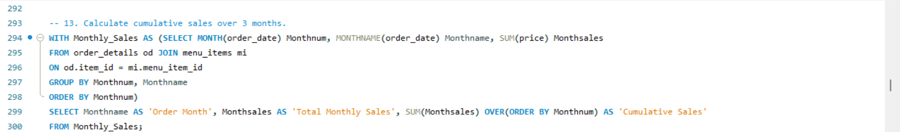

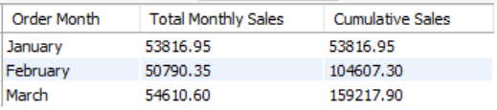

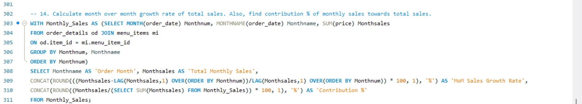

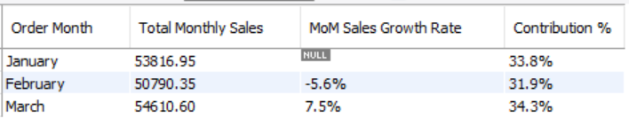

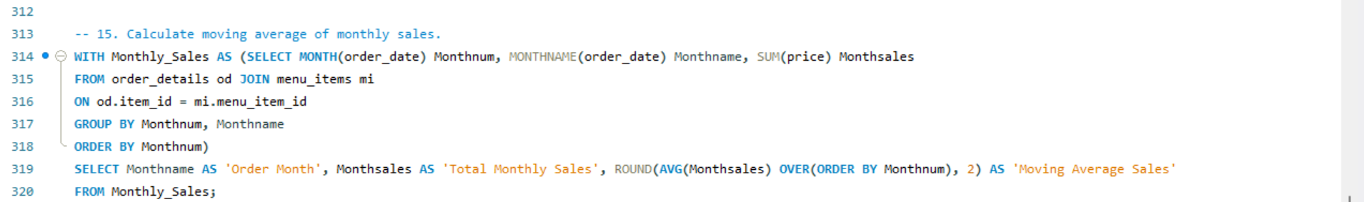

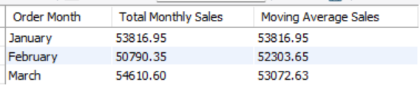

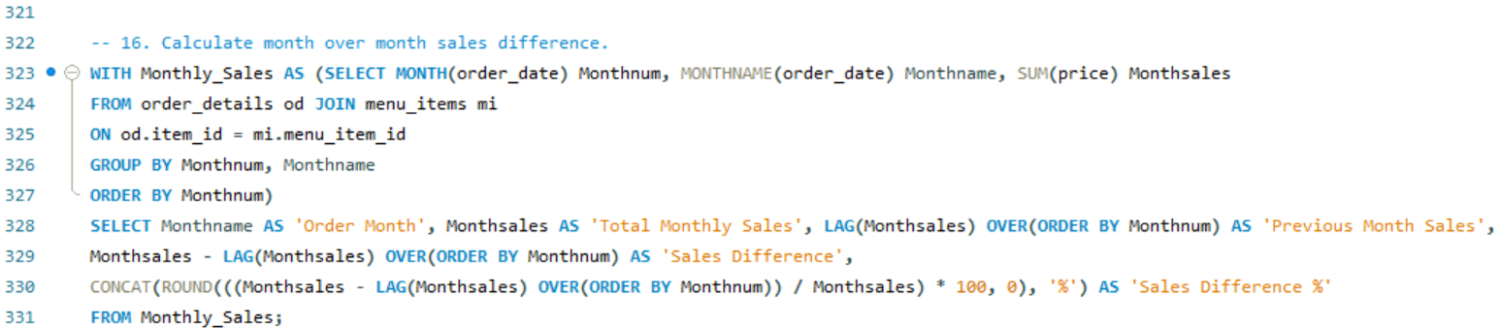

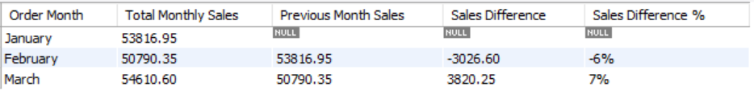

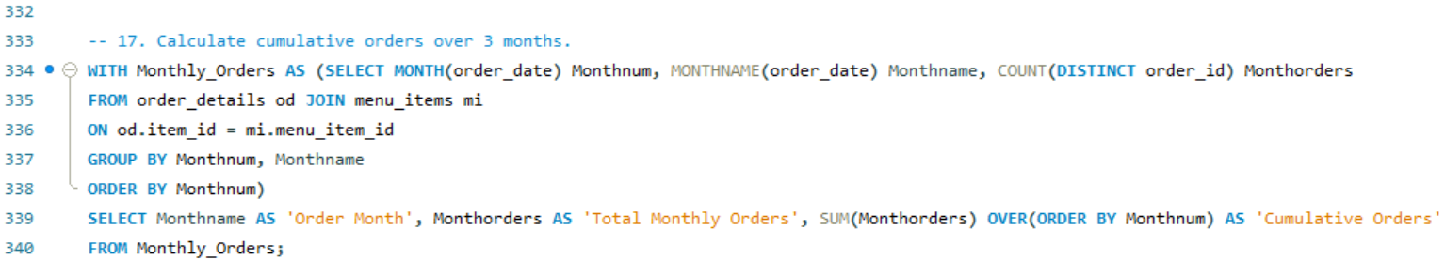

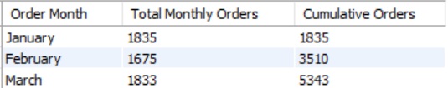

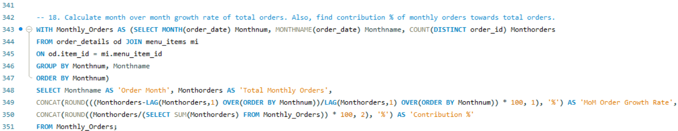

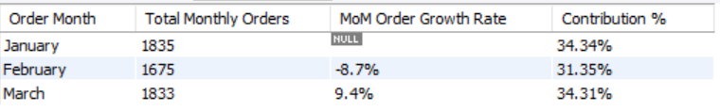

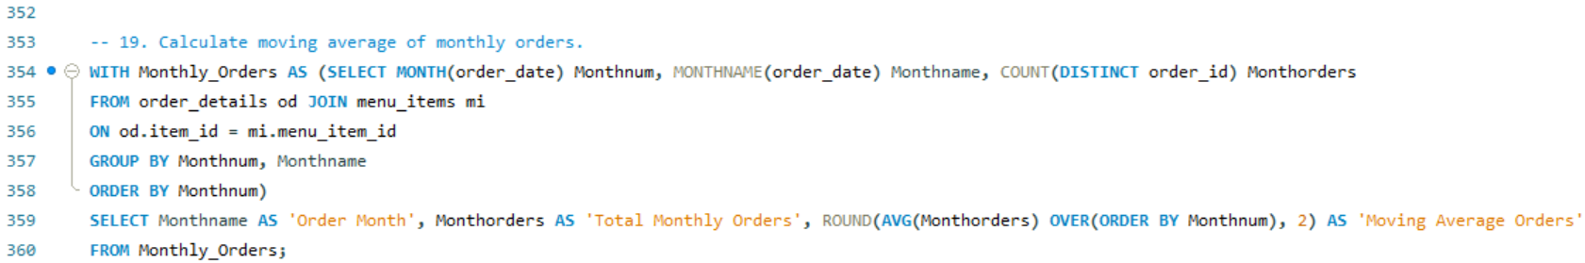

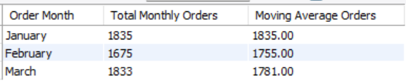

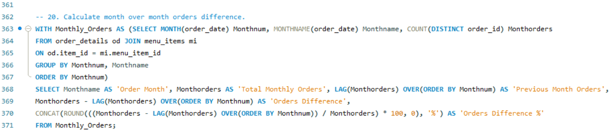

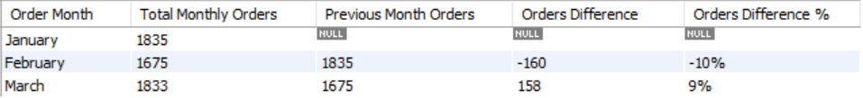

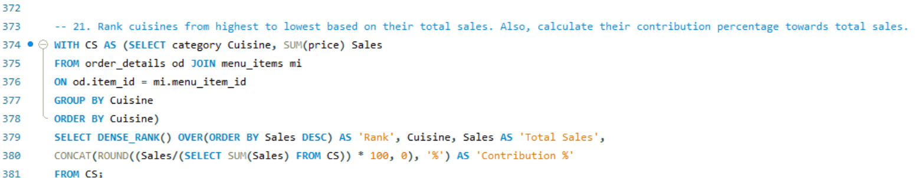

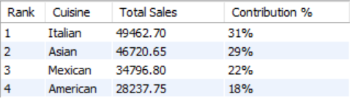

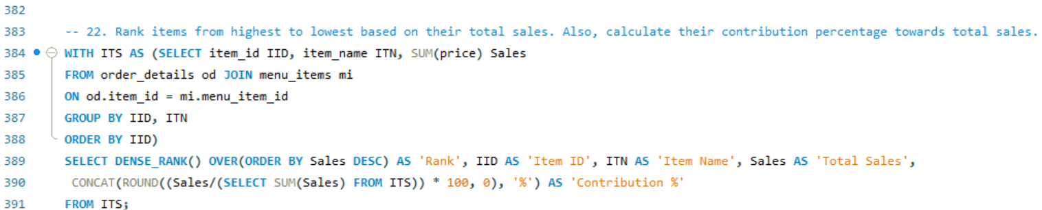

|  |  |  |  |  |
| --- | --- | --- | --- | --- |
| Rank | Item ID | Item Name | Total Sales | Contribution % |
| 1 | 109 | Korean Beef Bowl | 10554.60 | 7% |
| 2 | 125 | Spaghetti & Meatballs | 8436.50 | 5% |
| 3 | 108 | Tofu Pad Thai | 8149.00 | 5% |
| 4 | 102 | Cheeseburger | 8132.85 | 5% |
| 5 | 101 | Hamburger | 8054.90 | 5% |
| 6 | 107 | Orange Chicken | 7524.00 | 5% |
| 7 | 132 | Eggplant Parmesan | 7119.00 | 4% |
| 8 | 120 | Steak Torta | 6821.55 | 4% |
| 9 | 131 | Chicken Parmesan | 6533.80 | 4% |
| 10 | 110 | Pork Ramen | 6462.00 | 4% |
| 11 | 117 | Chicken Burrito | 5892.25 | 4% |
| 12 | 129 | Mushroom Ravioli | 5564.50 | 3% |
| 13 | 124 | Spaghetti | 5321.50 | 3% |
| 14 | 118 | Steak Burrito | 5292.30 | 3% |
| 15 | 127 | Meat Lasagna | 4900.35 | 3% |
| 16 | 112 | Salmon Roll | 4843.80 | 3% |
| 17 | 130 | Shrimp Scampi | 4768.05 | 3% |
| 18 | 119 | Chicken Torta | 4529.05 | 3% |
| 19 | 111 | California Roll | 4242.25 | 3% |
| 20 | 106 | French Fries | 3997.00 | 3% |
| 21 | 126 | Fettuccine Alfredo | 3610.50 | 2% |
| 22 | 105 | Mac & Cheese | 3241.00 | 2% |
| 23 | 122 | Chips & Salsa | 3227.00 | 2% |
| 24 | 128 | Cheese Lasagna | 3208.50 | 2% |
| 25 | 113 | Edamame | 3100.00 | 2% |
| 26 | 116 | Steak Tacos | 2985.30 | 2% |
| 27 | 104 | Veggie Burger | 2499.00 | 2% |
| 28 | 121 | Cheese Quesadillas | 2446.50 | 2% |
| 29 | 103 | Hot Dog | 2313.00 | 1% |
| 30 | 123 | Chips & Guacamole | 2133.00 | 1% |
| 31 | 114 | Potstickers | 1845.00 | 1% |
| 32 | 115 | Chicken Tacos | 1469.85 | 1% |

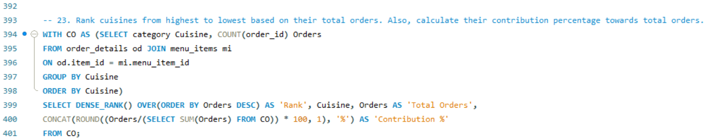

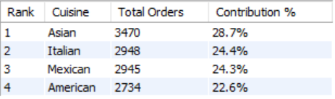

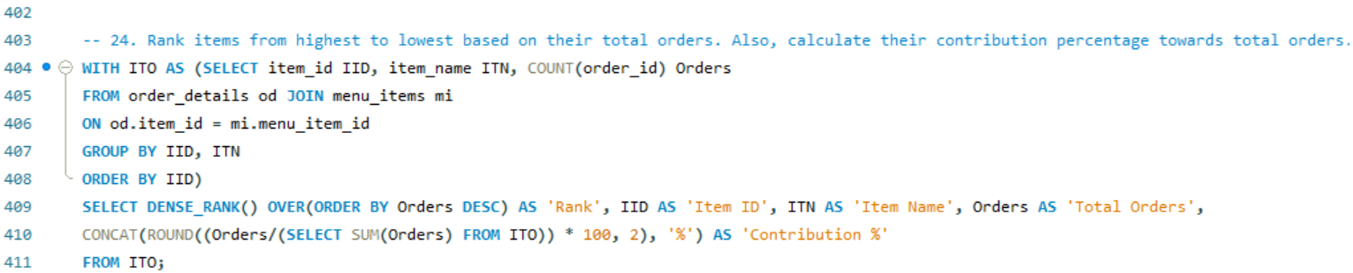

|  |  |  |  |  |
| --- | --- | --- | --- | --- |
| Rank | Item ID | Item Name | Total Orders | Contribution % |
| 1 | 101 | Hamburger | 622 | 5.14% |
| 2 | 113 | Edamame | 620 | 5.13% |
| 3 | 109 | Korean Beef Bowl | 588 | 4.86% |
| 4 | 102 | Cheeseburger | 583 | 4.82% |
| 5 | 106 | French Fries | 571 | 4.72% |
| 6 | 108 | Tofu Pad Thai | 562 | 4.65% |
| 7 | 120 | Steak Torta | 489 | 4.04% |
| 8 | 125 | Spaghetti & Meatballs | 470 | 3.89% |
| 9 | 105 | Mac & Cheese | 463 | 3.83% |
| 10 | 122 | Chips & Salsa | 461 | 3.81% |
| 11 | 107 | Orange Chicken | 456 | 3.77% |
| 12 | 117 | Chicken Burrito | 455 | 3.76% |
| 13 | 132 | Eggplant Parmesan | 420 | 3.47% |
| 14 | 119 | Chicken Torta | 379 | 3.13% |
| 15 | 124 | Spaghetti | 367 | 3.03% |
| 16 | 131 | Chicken Parmesan | 364 | 3.01% |
| 17 | 110 | Pork Ramen | 360 | 2.98% |
| 18 | 129 | Mushroom Ravioli | 359 | 2.97% |
| 19 | 111 | California Roll | 355 | 2.93% |
| 20 | 118 | Steak Burrito | 354 | 2.93% |
| 21 | 112 | Salmon Roll | 324 | 2.68% |
| 22 | 127 | Meat Lasagna | 273 | 2.26% |
| 23 | 103 | Hot Dog | 257 | 2.12% |
| 24 | 126 | Fettuccine Alfredo | 249 | 2.06% |
| 25 | 130 | Shrimp Scampi | 239 | 1.98% |
| 26 | 104 | Veggie Burger | 238 | 1.97% |
| 27 | 123 | Chips & Guacamole | 237 | 1.96% |
| 28 | 121 | Cheese Quesadillas | 233 | 1.93% |
| 29 | 116 | Steak Tacos | 214 | 1.77% |
| 30 | 128 | Cheese Lasagna | 207 | 1.71% |
| 31 | 114 | Potstickers | 205 | 1.69% |
| 32 | 115 | Chicken Tacos | 123 | 1.02% |

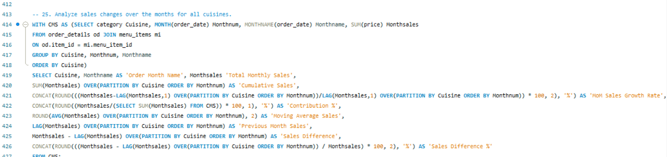

|  |  |  |  |  |  |  |  |  |  |
| --- | --- | --- | --- | --- | --- | --- | --- | --- | --- |
| Cuisine | Order Month Name | Total Monthly Sales | Cumulative Sales | MoM Sales Growth Rate | Contribution % | Moving Average Sales | Previous Month Sales | Sales Difference | Sales Difference % |
| American | January | 9284.85 | 9284.85 |  | 5.8% | 9284.85 |  |  |  |
| American | February | 8947.15 | 18232.00 | -3.64% | 5.6% | 9116.00 | 9284.85 | -337.70 | -3.77% |
| American | March | 10005.75 | 28237.75 | 11.83% | 6.3% | 9412.58 | 8947.15 | 1058.60 | 10.58% |
| Asian | January | 15588.50 | 15588.50 |  | 9.8% | 15588.50 |  |  |  |
| Asian | February | 15075.70 | 30664.20 | -3.29% | 9.5% | 15332.10 | 15588.50 | -512.80 | -3.40% |
| Asian | March | 16056.45 | 46720.65 | 6.51% | 10.1% | 15573.55 | 15075.70 | 980.75 | 6.11% |
| Italian | January | 16727.75 | 16727.75 |  | 10.5% | 16727.75 |  |  |  |
| Italian | February | 15545.05 | 32272.80 | -7.07% | 9.8% | 16136.40 | 16727.75 | -1182.70 | -7.61% |
| Italian | March | 17189.90 | 49462.70 | 10.58% | 10.8% | 16487.57 | 15545.05 | 1644.85 | 9.57% |
| Mexican | January | 12215.85 | 12215.85 |  | 7.7% | 12215.85 |  |  |  |
| Mexican | February | 11222.45 | 23438.30 | -8.13% | 7.0% | 11719.15 | 12215.85 | -993.40 | -8.85% |
| Mexican | March | 11358.50 | 34796.80 | 1.21% | 7.1% | 11598.93 | 11222.45 | 136.05 | 1.20% |

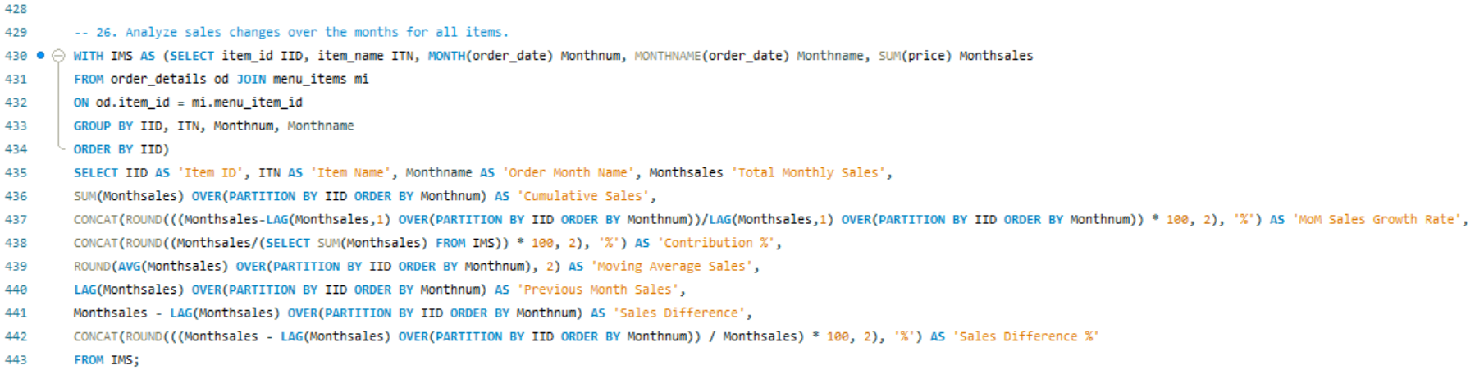

|  |  |  |  |  |  |  |  |  |  |  |
| --- | --- | --- | --- | --- | --- | --- | --- | --- | --- | --- |
| Item ID | Item Name | Order Month Name | Total Monthly Sales | Cumulative Sales | MoM Sales Growth Rate | Contribution % | Moving Average Sales | Previous Month Sales | Sales Difference | Sales Difference % |
| 101 | Hamburger | January | 2667.70 | 2667.70 |  | 1.68% | 2667.70 |  |  |  |
| 101 | Hamburger | February | 2421.65 | 5089.35 | -9.22% | 1.52% | 2544.68 | 2667.70 | -246.05 | -10.16% |
| 101 | Hamburger | March | 2965.55 | 8054.90 | 22.46% | 1.86% | 2684.97 | 2421.65 | 543.90 | 18.34% |
| 102 | Cheeseburger | January | 2748.15 | 2748.15 |  | 1.73% | 2748.15 |  |  |  |
| 102 | Cheeseburger | February | 2790.00 | 5538.15 | 1.52% | 1.75% | 2769.08 | 2748.15 | 41.85 | 1.50% |
| 102 | Cheeseburger | March | 2594.70 | 8132.85 | -7.00% | 1.63% | 2710.95 | 2790.00 | -195.30 | -7.53% |
| 103 | Hot Dog | January | 747.00 | 747.00 |  | 0.47% | 747.00 |  |  |  |
| 103 | Hot Dog | February | 666.00 | 1413.00 | -10.84% | 0.42% | 706.50 | 747.00 | -81.00 | -12.16% |
| 103 | Hot Dog | March | 900.00 | 2313.00 | 35.14% | 0.57% | 771.00 | 666.00 | 234.00 | 26.00% |
| 104 | Veggie Burger | January | 798.00 | 798.00 |  | 0.50% | 798.00 |  |  |  |
| 104 | Veggie Burger | February | 850.50 | 1648.50 | 6.58% | 0.53% | 824.25 | 798.00 | 52.50 | 6.17% |
| 104 | Veggie Burger | March | 850.50 | 2499.00 | 0.00% | 0.53% | 833.00 | 850.50 | 0.00 | 0.00% |
| 105 | Mac & Cheese | January | 945.00 | 945.00 |  | 0.59% | 945.00 |  |  |  |
| 105 | Mac & Cheese | February | 1071.00 | 2016.00 | 13.33% | 0.67% | 1008.00 | 945.00 | 126.00 | 11.76% |
| 105 | Mac & Cheese | March | 1225.00 | 3241.00 | 14.38% | 0.77% | 1080.33 | 1071.00 | 154.00 | 12.57% |
| 106 | French Fries | January | 1379.00 | 1379.00 |  | 0.87% | 1379.00 |  |  |  |
| 106 | French Fries | February | 1148.00 | 2527.00 | -16.75% | 0.72% | 1263.50 | 1379.00 | -231.00 | -20.12% |
| 106 | French Fries | March | 1470.00 | 3997.00 | 28.05% | 0.92% | 1332.33 | 1148.00 | 322.00 | 21.90% |
| 107 | Orange Chicken | January | 2409.00 | 2409.00 |  | 1.51% | 2409.00 |  |  |  |
| 107 | Orange Chicken | February | 2376.00 | 4785.00 | -1.37% | 1.49% | 2392.50 | 2409.00 | -33.00 | -1.39% |
| 107 | Orange Chicken | March | 2739.00 | 7524.00 | 15.28% | 1.72% | 2508.00 | 2376.00 | 363.00 | 13.25% |
| 108 | Tofu Pad Thai | January | 2740.50 | 2740.50 |  | 1.72% | 2740.50 |  |  |  |
| 108 | Tofu Pad Thai | February | 2508.50 | 5249.00 | -8.47% | 1.58% | 2624.50 | 2740.50 | -232.00 | -9.25% |
| 108 | Tofu Pad Thai | March | 2900.00 | 8149.00 | 15.61% | 1.82% | 2716.33 | 2508.50 | 391.50 | 13.50% |
| 109 | Korean Beef Bowl | January | 3266.90 | 3266.90 |  | 2.05% | 3266.90 |  |  |  |
| 109 | Korean Beef Bowl | February | 3482.30 | 6749.20 | 6.59% | 2.19% | 3374.60 | 3266.90 | 215.40 | 6.19% |
| 109 | Korean Beef Bowl | March | 3805.40 | 10554.60 | 9.28% | 2.39% | 3518.20 | 3482.30 | 323.10 | 8.49% |
| 110 | Pork Ramen | January | 2189.90 | 2189.90 |  | 1.38% | 2189.90 |  |  |  |
| 110 | Pork Ramen | February | 2171.95 | 4361.85 | -0.82% | 1.36% | 2180.93 | 2189.90 | -17.95 | -0.83% |
| 110 | Pork Ramen | March | 2100.15 | 6462.00 | -3.31% | 1.32% | 2154.00 | 2171.95 | -71.80 | -3.42% |
| 111 | California Roll | January | 1613.25 | 1613.25 |  | 1.01% | 1613.25 |  |  |  |
| 111 | California Roll | February | 1350.35 | 2963.60 | -16.30% | 0.85% | 1481.80 | 1613.25 | -262.90 | -19.47% |
| 111 | California Roll | March | 1278.65 | 4242.25 | -5.31% | 0.80% | 1414.08 | 1350.35 | -71.70 | -5.61% |
| 112 | Salmon Roll | January | 1509.95 | 1509.95 |  | 0.95% | 1509.95 |  |  |  |
| 112 | Salmon Roll | February | 1614.60 | 3124.55 | 6.93% | 1.01% | 1562.28 | 1509.95 | 104.65 | 6.48% |
| 112 | Salmon Roll | March | 1719.25 | 4843.80 | 6.48% | 1.08% | 1614.60 | 1614.60 | 104.65 | 6.09% |
| 113 | Edamame | January | 1175.00 | 1175.00 |  | 0.74% | 1175.00 |  |  |  |
| 113 | Edamame | February | 1005.00 | 2180.00 | -14.47% | 0.63% | 1090.00 | 1175.00 | -170.00 | -16.92% |
| 113 | Edamame | March | 920.00 | 3100.00 | -8.46% | 0.58% | 1033.33 | 1005.00 | -85.00 | -9.24% |
| 114 | Potstickers | January | 684.00 | 684.00 |  | 0.43% | 684.00 |  |  |  |
| 114 | Potstickers | February | 567.00 | 1251.00 | -17.11% | 0.36% | 625.50 | 684.00 | -117.00 | -20.63% |
| 114 | Potstickers | March | 594.00 | 1845.00 | 4.76% | 0.37% | 615.00 | 567.00 | 27.00 | 4.55% |
| 115 | Chicken Tacos | January | 406.30 | 406.30 |  | 0.26% | 406.30 |  |  |  |
| 115 | Chicken Tacos | February | 525.80 | 932.10 | 29.41% | 0.33% | 466.05 | 406.30 | 119.50 | 22.73% |
| 115 | Chicken Tacos | March | 537.75 | 1469.85 | 2.27% | 0.34% | 489.95 | 525.80 | 11.95 | 2.22% |
| 116 | Steak Tacos | January | 920.70 | 920.70 |  | 0.58% | 920.70 |  |  |  |
| 116 | Steak Tacos | February | 1185.75 | 2106.45 | 28.79% | 0.74% | 1053.23 | 920.70 | 265.05 | 22.35% |
| 116 | Steak Tacos | March | 878.85 | 2985.30 | -25.88% | 0.55% | 995.10 | 1185.75 | -306.90 | -34.92% |
| 117 | Chicken Burrito | January | 2149.70 | 2149.70 |  | 1.35% | 2149.70 |  |  |  |
| 117 | Chicken Burrito | February | 1825.95 | 3975.65 | -15.06% | 1.15% | 1987.83 | 2149.70 | -323.75 | -17.73% |
| 117 | Chicken Burrito | March | 1916.60 | 5892.25 | 4.96% | 1.20% | 1964.08 | 1825.95 | 90.65 | 4.73% |
| 118 | Steak Burrito | January | 1913.60 | 1913.60 |  | 1.20% | 1913.60 |  |  |  |
| 118 | Steak Burrito | February | 1599.65 | 3513.25 | -16.41% | 1.00% | 1756.63 | 1913.60 | -313.95 | -19.63% |
| 118 | Steak Burrito | March | 1779.05 | 5292.30 | 11.21% | 1.12% | 1764.10 | 1599.65 | 179.40 | 10.08% |
| 119 | Chicken Torta | January | 1589.35 | 1589.35 |  | 1.00% | 1589.35 |  |  |  |
| 119 | Chicken Torta | February | 1434.00 | 3023.35 | -9.77% | 0.90% | 1511.68 | 1589.35 | -155.35 | -10.83% |
| 119 | Chicken Torta | March | 1505.70 | 4529.05 | 5.00% | 0.95% | 1509.68 | 1434.00 | 71.70 | 4.76% |
| 120 | Steak Torta | January | 2594.70 | 2594.70 |  | 1.63% | 2594.70 |  |  |  |
| 120 | Steak Torta | February | 2148.30 | 4743.00 | -17.20% | 1.35% | 2371.50 | 2594.70 | -446.40 | -20.78% |
| 120 | Steak Torta | March | 2078.55 | 6821.55 | -3.25% | 1.31% | 2273.85 | 2148.30 | -69.75 | -3.36% |
| 121 | Cheese Quesadillas | January | 829.50 | 829.50 |  | 0.52% | 829.50 |  |  |  |
| 121 | Cheese Quesadillas | February | 798.00 | 1627.50 | -3.80% | 0.50% | 813.75 | 829.50 | -31.50 | -3.95% |
| 121 | Cheese Quesadillas | March | 819.00 | 2446.50 | 2.63% | 0.51% | 815.50 | 798.00 | 21.00 | 2.56% |
| 122 | Chips & Salsa | January | 1029.00 | 1029.00 |  | 0.65% | 1029.00 |  |  |  |
| 122 | Chips & Salsa | February | 994.00 | 2023.00 | -3.40% | 0.62% | 1011.50 | 1029.00 | -35.00 | -3.52% |
| 122 | Chips & Salsa | March | 1204.00 | 3227.00 | 21.13% | 0.76% | 1075.67 | 994.00 | 210.00 | 17.44% |
| 123 | Chips & Guacamole | January | 783.00 | 783.00 |  | 0.49% | 783.00 |  |  |  |
| 123 | Chips & Guacamole | February | 711.00 | 1494.00 | -9.20% | 0.45% | 747.00 | 783.00 | -72.00 | -10.13% |
| 123 | Chips & Guacamole | March | 639.00 | 2133.00 | -10.13% | 0.40% | 711.00 | 711.00 | -72.00 | -11.27% |
| 124 | Spaghetti | January | 1943.00 | 1943.00 |  | 1.22% | 1943.00 |  |  |  |
| 124 | Spaghetti | February | 1624.00 | 3567.00 | -16.42% | 1.02% | 1783.50 | 1943.00 | -319.00 | -19.64% |
| 124 | Spaghetti | March | 1754.50 | 5321.50 | 8.04% | 1.10% | 1773.83 | 1624.00 | 130.50 | 7.44% |
| 125 | Spaghetti & Meatballs | January | 2746.35 | 2746.35 |  | 1.72% | 2746.35 |  |  |  |
| 125 | Spaghetti & Meatballs | February | 2746.35 | 5492.70 | 0.00% | 1.72% | 2746.35 | 2746.35 | 0.00 | 0.00% |
| 125 | Spaghetti & Meatballs | March | 2943.80 | 8436.50 | 7.19% | 1.85% | 2812.17 | 2746.35 | 197.45 | 6.71% |
| 126 | Fettuccine Alfredo | January | 1073.00 | 1073.00 |  | 0.67% | 1073.00 |  |  |  |
| 126 | Fettuccine Alfredo | February | 1276.00 | 2349.00 | 18.92% | 0.80% | 1174.50 | 1073.00 | 203.00 | 15.91% |
| 126 | Fettuccine Alfredo | March | 1261.50 | 3610.50 | -1.14% | 0.79% | 1203.50 | 1276.00 | -14.50 | -1.15% |
| 127 | Meat Lasagna | January | 1795.00 | 1795.00 |  | 1.13% | 1795.00 |  |  |  |
| 127 | Meat Lasagna | February | 1561.65 | 3356.65 | -13.00% | 0.98% | 1678.33 | 1795.00 | -233.35 | -14.94% |
| 127 | Meat Lasagna | March | 1543.70 | 4900.35 | -1.15% | 0.97% | 1633.45 | 1561.65 | -17.95 | -1.16% |
| 128 | Cheese Lasagna | January | 1023.00 | 1023.00 |  | 0.64% | 1023.00 |  |  |  |
| 128 | Cheese Lasagna | February | 992.00 | 2015.00 | -3.03% | 0.62% | 1007.50 | 1023.00 | -31.00 | -3.13% |
| 128 | Cheese Lasagna | March | 1193.50 | 3208.50 | 20.31% | 0.75% | 1069.50 | 992.00 | 201.50 | 16.88% |
| 129 | Mushroom Ravioli | January | 1999.50 | 1999.50 |  | 1.26% | 1999.50 |  |  |  |
| 129 | Mushroom Ravioli | February | 1612.00 | 3611.50 | -19.38% | 1.01% | 1805.75 | 1999.50 | -387.50 | -24.04% |
| 129 | Mushroom Ravioli | March | 1953.00 | 5564.50 | 21.15% | 1.23% | 1854.83 | 1612.00 | 341.00 | 17.46% |
| 130 | Shrimp Scampi | January | 1516.20 | 1516.20 |  | 0.95% | 1516.20 |  |  |  |
| 130 | Shrimp Scampi | February | 1456.35 | 2972.55 | -3.95% | 0.91% | 1486.28 | 1516.20 | -59.85 | -4.11% |
| 130 | Shrimp Scampi | March | 1795.50 | 4768.05 | 23.29% | 1.13% | 1589.35 | 1456.35 | 339.15 | 18.89% |
| 131 | Chicken Parmesan | January | 2207.85 | 2207.85 |  | 1.39% | 2207.85 |  |  |  |
| 131 | Chicken Parmesan | February | 1920.65 | 4128.50 | -13.01% | 1.21% | 2064.25 | 2207.85 | -287.20 | -14.95% |
| 131 | Chicken Parmesan | March | 2405.30 | 6533.80 | 25.23% | 1.51% | 2177.93 | 1920.65 | 484.65 | 20.15% |
| 132 | Eggplant Parmesan | January | 2423.85 | 2423.85 |  | 1.52% | 2423.85 |  |  |  |
| 132 | Eggplant Parmesan | February | 2356.05 | 4779.90 | -2.80% | 1.48% | 2389.95 | 2423.85 | -67.80 | -2.88% |
| 132 | Eggplant Parmesan | March | 2339.10 | 7119.00 | -0.72% | 1.47% | 2373.00 | 2356.05 | -16.95 | -0.72% |

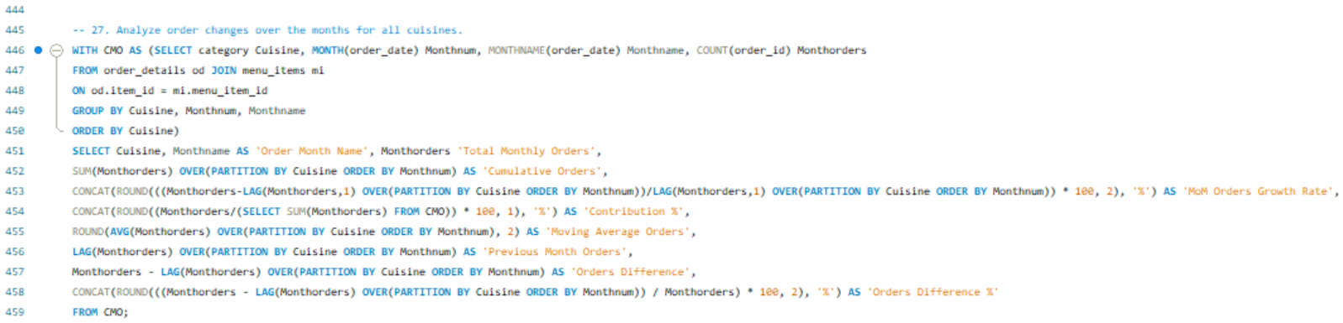

|  |  |  |  |  |  |  |  |  |  |
| --- | --- | --- | --- | --- | --- | --- | --- | --- | --- |
| Cuisine | Order Month Name | Total Monthly Orders | Cumulative Orders | MoM Orders Growth Rate | Contribution % | Moving Average Orders | Previous Month Orders | Orders Difference | Orders Difference % |
| American | January | 894 | 894 |  | 7.4% | 894.00 |  |  |  |
| American | February | 859 | 1753 | -3.91% | 7.1% | 876.50 | 894 | -35 | -4.07% |
| American | March | 981 | 2734 | 14.20% | 8.1% | 911.33 | 859 | 122 | 12.44% |
| Asian | January | 1186 | 1186 |  | 9.8% | 1186.00 |  |  |  |
| Asian | February | 1117 | 2303 | -5.82% | 9.2% | 1151.50 | 1186 | -69 | -6.18% |
| Asian | March | 1167 | 3470 | 4.48% | 9.6% | 1156.67 | 1117 | 50 | 4.28% |
| Italian | January | 998 | 998 |  | 8.2% | 998.00 |  |  |  |
| Italian | February | 927 | 1925 | -7.11% | 7.7% | 962.50 | 998 | -71 | -7.66% |
| Italian | March | 1023 | 2948 | 10.36% | 8.5% | 982.67 | 927 | 96 | 9.38% |
| Mexican | January | 1026 | 1026 |  | 8.5% | 1026.00 |  |  |  |
| Mexican | February | 948 | 1974 | -7.60% | 7.8% | 987.00 | 1026 | -78 | -8.23% |
| Mexican | March | 971 | 2945 | 2.43% | 8.0% | 981.67 | 948 | 23 | 2.37% |

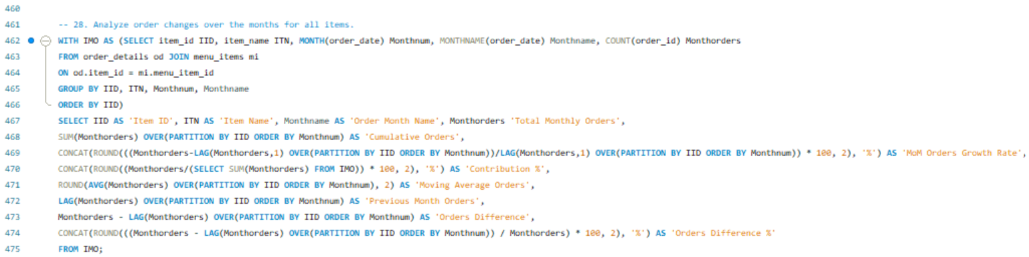

|  |  |  |  |  |  |  |  |  |  |  |
| --- | --- | --- | --- | --- | --- | --- | --- | --- | --- | --- |
| Item ID | Item Name | Order Month Name | Total Monthly Orders | Cumulative Orders | MoM Orders Growth Rate | Contribution % | Moving Average Orders | Previous Month Orders | Orders Difference | Orders Difference % |
| 101 | Hamburger | January | 206 | 206 |  | 1.70% | 206.00 |  |  |  |
| 101 | Hamburger | February | 187 | 393 | -9.22% | 1.55% | 196.50 | 206 | -19 | -10.16% |
| 101 | Hamburger | March | 229 | 622 | 22.46% | 1.89% | 207.33 | 187 | 42 | 18.34% |
| 102 | Cheeseburger | January | 197 | 197 |  | 1.63% | 197.00 |  |  |  |
| 102 | Cheeseburger | February | 200 | 397 | 1.52% | 1.65% | 198.50 | 197 | 3 | 1.50% |
| 102 | Cheeseburger | March | 186 | 583 | -7.00% | 1.54% | 194.33 | 200 | -14 | -7.53% |
| 103 | Hot Dog | January | 83 | 83 |  | 0.69% | 83.00 |  |  |  |
| 103 | Hot Dog | February | 74 | 157 | -10.84% | 0.61% | 78.50 | 83 | -9 | -12.16% |
| 103 | Hot Dog | March | 100 | 257 | 35.14% | 0.83% | 85.67 | 74 | 26 | 26.00% |
| 104 | Veggie Burger | January | 76 | 76 |  | 0.63% | 76.00 |  |  |  |
| 104 | Veggie Burger | February | 81 | 157 | 6.58% | 0.67% | 78.50 | 76 | 5 | 6.17% |
| 104 | Veggie Burger | March | 81 | 238 | 0.00% | 0.67% | 79.33 | 81 | 0 | 0.00% |
| 105 | Mac & Cheese | January | 135 | 135 |  | 1.12% | 135.00 |  |  |  |
| 105 | Mac & Cheese | February | 153 | 288 | 13.33% | 1.26% | 144.00 | 135 | 18 | 11.76% |
| 105 | Mac & Cheese | March | 175 | 463 | 14.38% | 1.45% | 154.33 | 153 | 22 | 12.57% |
| 106 | French Fries | January | 197 | 197 |  | 1.63% | 197.00 |  |  |  |
| 106 | French Fries | February | 164 | 361 | -16.75% | 1.36% | 180.50 | 197 | -33 | -20.12% |
| 106 | French Fries | March | 210 | 571 | 28.05% | 1.74% | 190.33 | 164 | 46 | 21.90% |
| 107 | Orange Chicken | January | 146 | 146 |  | 1.21% | 146.00 |  |  |  |
| 107 | Orange Chicken | February | 144 | 290 | -1.37% | 1.19% | 145.00 | 146 | -2 | -1.39% |
| 107 | Orange Chicken | March | 166 | 456 | 15.28% | 1.37% | 152.00 | 144 | 22 | 13.25% |
| 108 | Tofu Pad Thai | January | 189 | 189 |  | 1.56% | 189.00 |  |  |  |
| 108 | Tofu Pad Thai | February | 173 | 362 | -8.47% | 1.43% | 181.00 | 189 | -16 | -9.25% |
| 108 | Tofu Pad Thai | March | 200 | 562 | 15.61% | 1.65% | 187.33 | 173 | 27 | 13.50% |
| 109 | Korean Beef Bowl | January | 182 | 182 |  | 1.50% | 182.00 |  |  |  |
| 109 | Korean Beef Bowl | February | 194 | 376 | 6.59% | 1.60% | 188.00 | 182 | 12 | 6.19% |
| 109 | Korean Beef Bowl | March | 212 | 588 | 9.28% | 1.75% | 196.00 | 194 | 18 | 8.49% |
| 110 | Pork Ramen | January | 122 | 122 |  | 1.01% | 122.00 |  |  |  |
| 110 | Pork Ramen | February | 121 | 243 | -0.82% | 1.00% | 121.50 | 122 | -1 | -0.83% |
| 110 | Pork Ramen | March | 117 | 360 | -3.31% | 0.97% | 120.00 | 121 | -4 | -3.42% |
| 111 | California Roll | January | 135 | 135 |  | 1.12% | 135.00 |  |  |  |
| 111 | California Roll | February | 113 | 248 | -16.30% | 0.93% | 124.00 | 135 | -22 | -19.47% |
| 111 | California Roll | March | 107 | 355 | -5.31% | 0.88% | 118.33 | 113 | -6 | -5.61% |
| 112 | Salmon Roll | January | 101 | 101 |  | 0.83% | 101.00 |  |  |  |
| 112 | Salmon Roll | February | 108 | 209 | 6.93% | 0.89% | 104.50 | 101 | 7 | 6.48% |
| 112 | Salmon Roll | March | 115 | 324 | 6.48% | 0.95% | 108.00 | 108 | 7 | 6.09% |
| 113 | Edamame | January | 235 | 235 |  | 1.94% | 235.00 |  |  |  |
| 113 | Edamame | February | 201 | 436 | -14.47% | 1.66% | 218.00 | 235 | -34 | -16.92% |
| 113 | Edamame | March | 184 | 620 | -8.46% | 1.52% | 206.67 | 201 | -17 | -9.24% |
| 114 | Potstickers | January | 76 | 76 |  | 0.63% | 76.00 |  |  |  |
| 114 | Potstickers | February | 63 | 139 | -17.11% | 0.52% | 69.50 | 76 | -13 | -20.63% |
| 114 | Potstickers | March | 66 | 205 | 4.76% | 0.55% | 68.33 | 63 | 3 | 4.55% |
| 115 | Chicken Tacos | January | 34 | 34 |  | 0.28% | 34.00 |  |  |  |
| 115 | Chicken Tacos | February | 44 | 78 | 29.41% | 0.36% | 39.00 | 34 | 10 | 22.73% |
| 115 | Chicken Tacos | March | 45 | 123 | 2.27% | 0.37% | 41.00 | 44 | 1 | 2.22% |
| 116 | Steak Tacos | January | 66 | 66 |  | 0.55% | 66.00 |  |  |  |
| 116 | Steak Tacos | February | 85 | 151 | 28.79% | 0.70% | 75.50 | 66 | 19 | 22.35% |
| 116 | Steak Tacos | March | 63 | 214 | -25.88% | 0.52% | 71.33 | 85 | -22 | -34.92% |
| 117 | Chicken Burrito | January | 166 | 166 |  | 1.37% | 166.00 |  |  |  |
| 117 | Chicken Burrito | February | 141 | 307 | -15.06% | 1.17% | 153.50 | 166 | -25 | -17.73% |
| 117 | Chicken Burrito | March | 148 | 455 | 4.96% | 1.22% | 151.67 | 141 | 7 | 4.73% |
| 118 | Steak Burrito | January | 128 | 128 |  | 1.06% | 128.00 |  |  |  |
| 118 | Steak Burrito | February | 107 | 235 | -16.41% | 0.88% | 117.50 | 128 | -21 | -19.63% |
| 118 | Steak Burrito | March | 119 | 354 | 11.21% | 0.98% | 118.00 | 107 | 12 | 10.08% |
| 119 | Chicken Torta | January | 133 | 133 |  | 1.10% | 133.00 |  |  |  |
| 119 | Chicken Torta | February | 120 | 253 | -9.77% | 0.99% | 126.50 | 133 | -13 | -10.83% |
| 119 | Chicken Torta | March | 126 | 379 | 5.00% | 1.04% | 126.33 | 120 | 6 | 4.76% |
| 120 | Steak Torta | January | 186 | 186 |  | 1.54% | 186.00 |  |  |  |
| 120 | Steak Torta | February | 154 | 340 | -17.20% | 1.27% | 170.00 | 186 | -32 | -20.78% |
| 120 | Steak Torta | March | 149 | 489 | -3.25% | 1.23% | 163.00 | 154 | -5 | -3.36% |
| 121 | Cheese Quesadillas | January | 79 | 79 |  | 0.65% | 79.00 |  |  |  |
| 121 | Cheese Quesadillas | February | 76 | 155 | -3.80% | 0.63% | 77.50 | 79 | -3 | -3.95% |
| 121 | Cheese Quesadillas | March | 78 | 233 | 2.63% | 0.64% | 77.67 | 76 | 2 | 2.56% |
| 122 | Chips & Salsa | January | 147 | 147 |  | 1.22% | 147.00 |  |  |  |
| 122 | Chips & Salsa | February | 142 | 289 | -3.40% | 1.17% | 144.50 | 147 | -5 | -3.52% |
| 122 | Chips & Salsa | March | 172 | 461 | 21.13% | 1.42% | 153.67 | 142 | 30 | 17.44% |
| 123 | Chips & Guacamole | January | 87 | 87 |  | 0.72% | 87.00 |  |  |  |
| 123 | Chips & Guacamole | February | 79 | 166 | -9.20% | 0.65% | 83.00 | 87 | -8 | -10.13% |
| 123 | Chips & Guacamole | March | 71 | 237 | -10.13% | 0.59% | 79.00 | 79 | -8 | -11.27% |
| 124 | Spaghetti | January | 134 | 134 |  | 1.11% | 134.00 |  |  |  |
| 124 | Spaghetti | February | 112 | 246 | -16.42% | 0.93% | 123.00 | 134 | -22 | -19.64% |
| 124 | Spaghetti | March | 121 | 367 | 8.04% | 1.00% | 122.33 | 112 | 9 | 7.44% |
| 125 | Spaghetti & Meatballs | January | 153 | 153 |  | 1.26% | 153.00 |  |  |  |
| 125 | Spaghetti & Meatballs | February | 153 | 306 | 0.00% | 1.26% | 153.00 | 153 | 0 | 0.00% |
| 125 | Spaghetti & Meatballs | March | 164 | 470 | 7.19% | 1.36% | 156.67 | 153 | 11 | 6.71% |
| 126 | Fettuccine Alfredo | January | 74 | 74 |  | 0.61% | 74.00 |  |  |  |
| 126 | Fettuccine Alfredo | February | 88 | 162 | 18.92% | 0.73% | 81.00 | 74 | 14 | 15.91% |
| 126 | Fettuccine Alfredo | March | 87 | 249 | -1.14% | 0.72% | 83.00 | 88 | -1 | -1.15% |
| 127 | Meat Lasagna | January | 100 | 100 |  | 0.83% | 100.00 |  |  |  |
| 127 | Meat Lasagna | February | 87 | 187 | -13.00% | 0.72% | 93.50 | 100 | -13 | -14.94% |
| 127 | Meat Lasagna | March | 86 | 273 | -1.15% | 0.71% | 91.00 | 87 | -1 | -1.16% |
| 128 | Cheese Lasagna | January | 66 | 66 |  | 0.55% | 66.00 |  |  |  |
| 128 | Cheese Lasagna | February | 64 | 130 | -3.03% | 0.53% | 65.00 | 66 | -2 | -3.13% |
| 128 | Cheese Lasagna | March | 77 | 207 | 20.31% | 0.64% | 69.00 | 64 | 13 | 16.88% |
| 129 | Mushroom Ravioli | January | 129 | 129 |  | 1.07% | 129.00 |  |  |  |
| 129 | Mushroom Ravioli | February | 104 | 233 | -19.38% | 0.86% | 116.50 | 129 | -25 | -24.04% |
| 129 | Mushroom Ravioli | March | 126 | 359 | 21.15% | 1.04% | 119.67 | 104 | 22 | 17.46% |
| 130 | Shrimp Scampi | January | 76 | 76 |  | 0.63% | 76.00 |  |  |  |
| 130 | Shrimp Scampi | February | 73 | 149 | -3.95% | 0.60% | 74.50 | 76 | -3 | -4.11% |
| 130 | Shrimp Scampi | March | 90 | 239 | 23.29% | 0.74% | 79.67 | 73 | 17 | 18.89% |
| 131 | Chicken Parmesan | January | 123 | 123 |  | 1.02% | 123.00 |  |  |  |
| 131 | Chicken Parmesan | February | 107 | 230 | -13.01% | 0.88% | 115.00 | 123 | -16 | -14.95% |
| 131 | Chicken Parmesan | March | 134 | 364 | 25.23% | 1.11% | 121.33 | 107 | 27 | 20.15% |
| 132 | Eggplant Parmesan | January | 143 | 143 |  | 1.18% | 143.00 |  |  |  |
| 132 | Eggplant Parmesan | February | 139 | 282 | -2.80% | 1.15% | 141.00 | 143 | -4 | -2.88% |
| 132 | Eggplant Parmesan | March | 138 | 420 | -0.72% | 1.14% | 140.00 | 139 | -1 | -0.72% |